Name___________________________________

Quick Quiz

**Unit Rate 13**

Identify the unit rate:

1. 110 books read in 11 months 2. $y=24x$

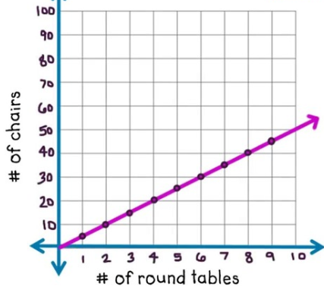 **_________ books per month unit rate =_________**

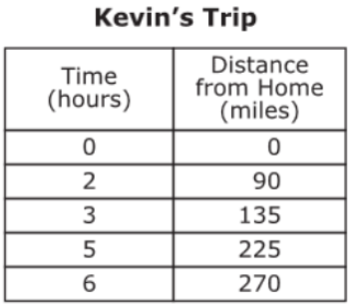3. 4.

**________ _______**

**miles per chairs per**

**hour table**

____________________________________________________________________________

Corrections

**Unit Rate 13**

Identify the unit rate:

1. 110 books read in 11 months 2.

 **_________ books per month unit rate =_________**

3. 4.

**________ _______**

**miles per chairs per**

**hour table**